Lovego Donation feedback

*In order to offer better service and provide the real help, we appreciated much for you to fill the form and email back to us. Lovego, go along with love*

User name: Application Date:

1. Which Lovego oxygen concentrator model did you receive?

LG101  LG102 LG102S LG1002

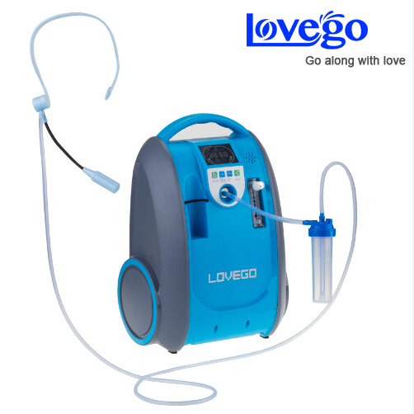 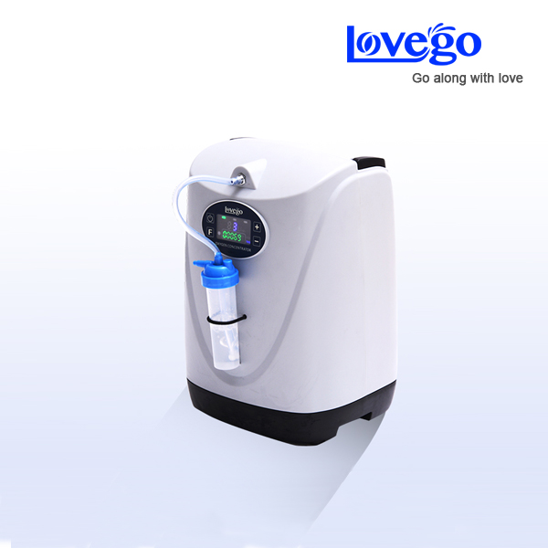 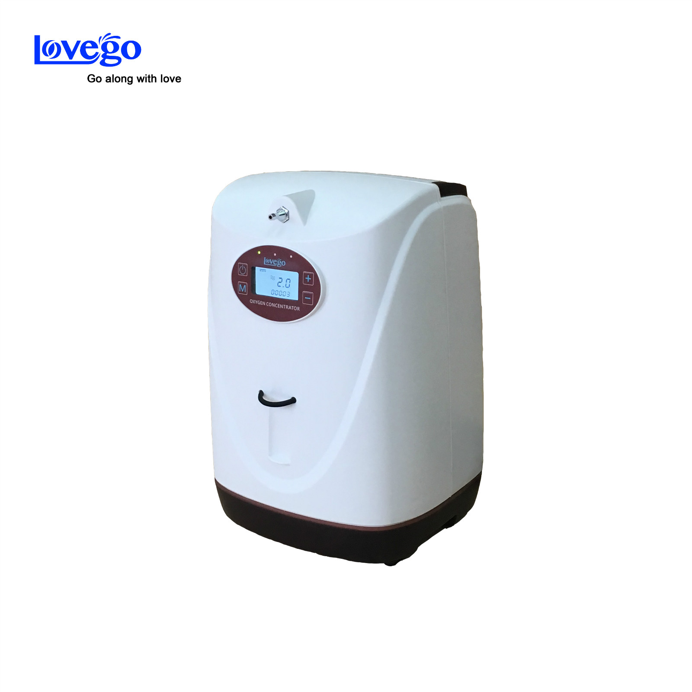 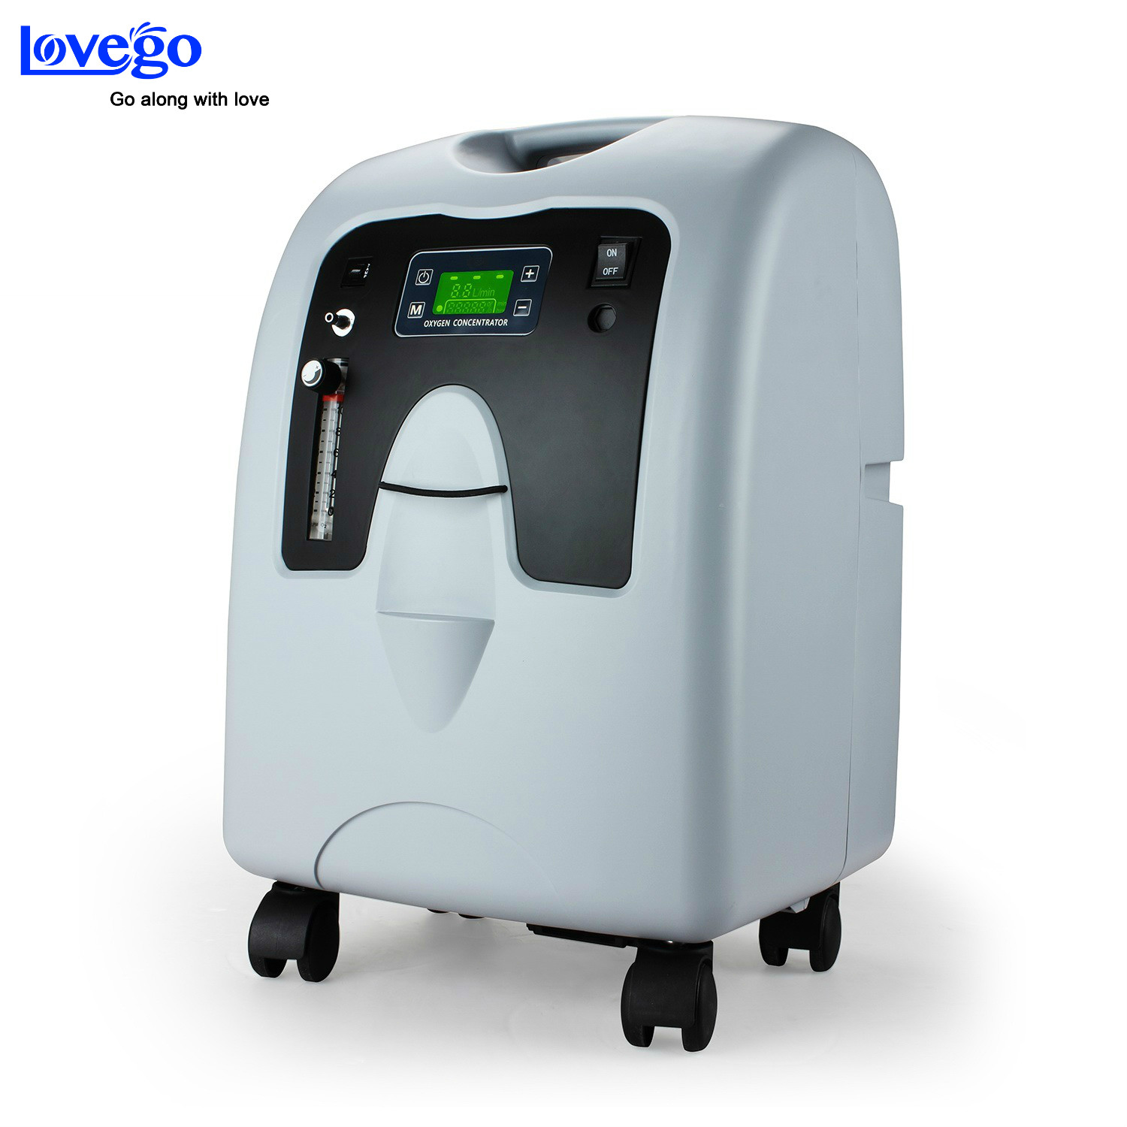

1. What is the oxygen flow do you use?

* 1-2LPM  2-3LPM 3-4LPM  5LPM or more

1. Comment for Lovego service?
2. Advices for Lovego service?
3. Comments and advices for the Lovego oxygen concentrator

